SIMATS ENGINEERING
ASSESSMENT TOOL 1
COURSE NAME: Artificial Intelligence COURSE CODE: CSA17
COURSE OUTCOME COVERED
CO5: Design AI-based systems using PySpark, RDD operations, and intelligent agent architectures, using scalable systems and integrate components in distributed AI applications. (BTL 5)
Assessment Tool Weightage: 50%
QUESTIONS: 5 Duration: 1 Hour Total Marks: 50
Annexure A
Design Task

Code of Conduct:
I M Praneeth Kumar(192372310) certify that this submission is my original work and that I have adhered to the guidelines specified for this assessment.
I understand that any violation of academic integrity rules will result in disciplinary action.
Signature of the student: M Praneeth Kumar

Design Task — Answers
Question 1: Hybrid AI Recommendation Engine Design
(Marks: 10)
1. Problem Understanding & Requirements
The goal is to design a recommendation engine that combines content-based filtering (matching item attributes to user preferences) with collaborative filtering (matching users with similar behavior) so that recommendations remain accurate even for new users or new items (the cold-start problem). The system must process large-scale, continuously growing user-item interaction data (clicks, ratings, purchases, watch time) and update recommendations in real time as user behavior changes.
2. System Architecture
- Data Ingestion Layer: Streams user events (clicks, ratings, views) via Kafka into a distributed store (HDFS/S3).
- Distributed Processing Layer (PySpark): Cleans, transforms, and models data using RDD/DataFrame operations across a cluster.
- Hybrid Model Layer: Content-based module (TF-IDF / cosine similarity on item metadata) and Collaborative module (Alternating Least Squares matrix factorization on the user-item rating matrix).
- Fusion Layer: Combines scores from both models using a weighted or learned ensemble to produce a final ranked list.
- Intelligent Agent Layer: Monitors feedback and dynamically adjusts weighting and re-ranking.
- Serving Layer: A low-latency API/cache (e.g., Redis) delivers recommendations to the application.
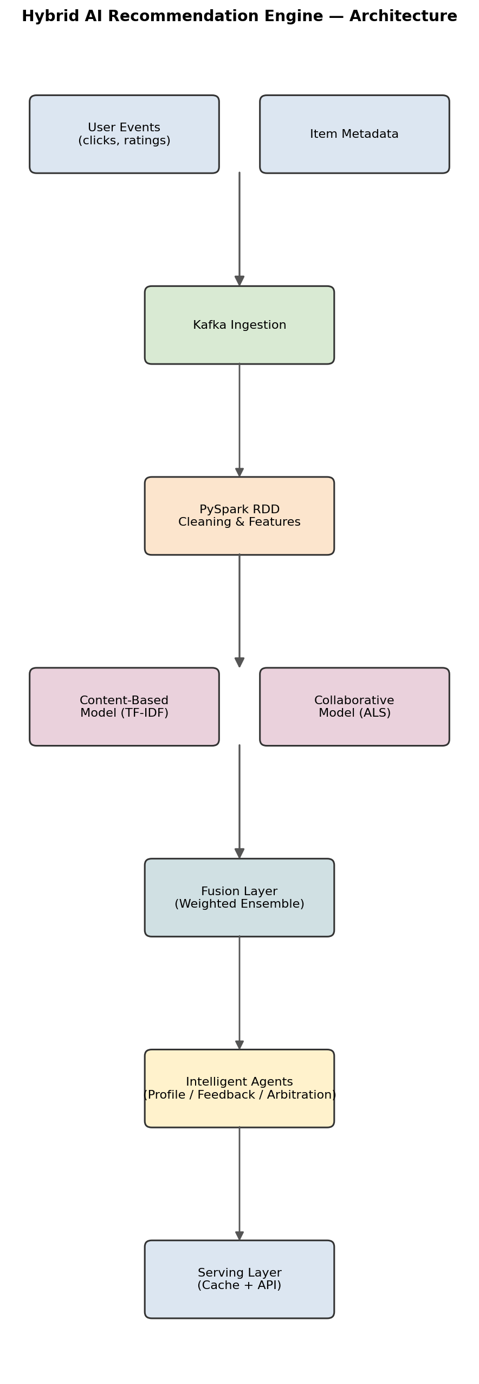
Figure 1.1 — Hybrid recommendation engine architecture (data flows top to bottom).
3. Use of PySpark & RDD Operations
Raw interaction logs are loaded as RDDs and processed with transformations such as map() to parse records, filter() to remove noise/invalid entries, groupByKey()/reduceByKey() to aggregate a user's interactions per item, and join() to combine user profiles with item metadata. Actions like collect() and take() are used sparingly (only for small aggregated results) to avoid pulling large datasets to the driver. RDD lineage gives fault tolerance: if a worker node fails mid-computation, Spark recomputes only the lost partitions instead of restarting the whole job. For matrix factorization, the user-item RDD is converted into Spark MLlib's Rating objects and trained using ALS, which itself partitions the sparse matrix across the cluster.
# Sample PySpark RDD pipeline for building the user-item rating matrix
ratings_rdd = sc.textFile("interactions.csv") \
.map(lambda line: line.split(",")) \
.filter(lambda x: len(x) == 3) \
.map(lambda x: (int(x[0]), int(x[1]), float(x[2])))

# Aggregate total interactions per user (reduceByKey)
user_activity = ratings_rdd.map(lambda x: (x[0], 1)) \
.reduceByKey(lambda a, b: a + b)

from pyspark.mllib.recommendation import ALS, Rating
training_data = ratings_rdd.map(lambda x: Rating(*x))
model = ALS.train(training_data, rank=10, iterations=10, lambda_=0.01)

Example: Sample Interaction Data & Fused Recommendation Output
User ID | Item | Content Score | Collaborative Score | Fused Score
U101 | Wireless Headphones | 0.82 | 0.74 | 0.79
U101 | Bluetooth Speaker | 0.65 | 0.88 | 0.75
U205 (new user) | Running Shoes | 0.90 | 0.20 (cold-start) | 0.68

4. Role of Intelligent Agents
- User-Profile Agent: Continuously updates each user's preference vector as new interactions arrive.
- Feedback Agent: Observes implicit signals (skips, dwell time) and explicit signals (likes/ratings) to reward or penalize recommended items, feeding a reinforcement-learning-style update loop.
- Arbitration Agent: Decides, per user, how much weight to give content-based vs collaborative scores (e.g., new users lean content-based; established users lean collaborative).
- Monitoring Agent: Detects concept drift (changing tastes) and triggers model retraining.
5. Scalability & Distributed Computing
Horizontal scaling is achieved by adding Spark worker nodes; data is partitioned by user-ID hash so related records stay co-located, minimizing shuffle. In-memory RDD caching (persist()) speeds up iterative ALS training. Fault tolerance comes from RDD lineage and Spark's speculative execution for straggler tasks.
Content-Based vs Collaborative Filtering — Comparison
Aspect | Content-Based Filtering | Collaborative Filtering
Uses | Item attributes/metadata | User-item interaction patterns
Cold-start (new item) | Handles well | Struggles
Cold-start (new user) | Struggles (no history) | Struggles
Diversity of results | Lower (similar items) | Higher (serendipity)

6. Data Flow & Processing Pipeline
Raw events → Kafka → Spark Structured Streaming (micro-batches) → RDD/DataFrame transformations → feature store → hybrid model scoring → fusion/re-ranking → cache → application. A parallel batch pipeline periodically retrains the ALS model offline on the full historical dataset.
7. Innovation & Impact
Using an adaptive weighting agent instead of a fixed hybrid formula lets the system self-tune per user segment, improving click-through rate and reducing cold-start latency compared to a static hybrid model.

Question 2: Smart Disaster Detection System
(Marks: 10)
1. Problem Understanding & Requirements
The system must fuse heterogeneous, high-velocity data — satellite imagery, IoT sensor readings (water level, seismic activity), and social media text — to detect disasters such as floods and earthquakes early, and issue timely, accurate warnings while minimizing false alarms.
2. System Architecture
- Data Source Layer: Satellite feeds, IoT sensor networks, and social media APIs (Twitter/X streams).
- Ingestion Layer: Kafka topics per source type feed into a distributed data lake.
- Distributed Processing Layer (PySpark): Separate RDD pipelines clean and featurize each modality in parallel.
- Data Fusion Layer: Combines normalized features from all three sources into a unified event representation.
- Intelligent Agent Layer: Region-based agents evaluate fused evidence and reach consensus on alert issuance.
- Alert & Response Layer: Pushes warnings to emergency services and public alert systems.
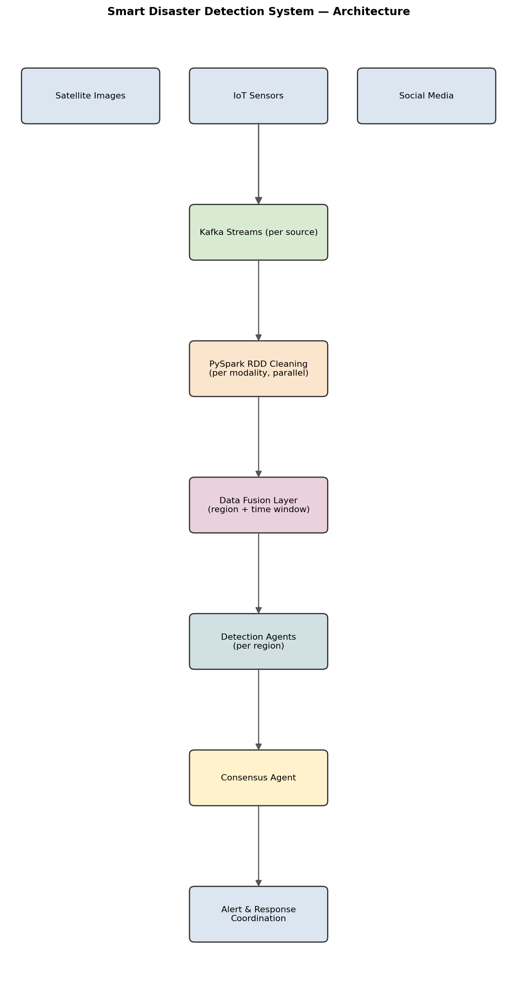
Figure 2.1 — Multi-source disaster detection and alerting architecture.
3. Use of PySpark & RDD Operations
Sensor RDDs use map() to convert raw voltage/readings into physical units and filter() to drop faulty sensor data. Satellite image metadata RDDs are processed with flatMap() to extract patches for change-detection scoring. Social media text RDDs use map()/filter() for keyword and geolocation extraction, then reduceByKey() to aggregate mention counts per region and time window. A union() combines the three normalized RDDs by region-ID key, followed by a join()/cogroup() to build the fused feature vector per region per time window.
# Fusing sensor, satellite, and social-media RDDs by region + time window
sensor_rdd = raw_sensor.map(lambda r: (r.region_id, ("sensor", r.water_level)))
social_rdd = raw_posts.filter(lambda p: p.geo is not None) \
.map(lambda p: (p.region_id, ("social", 1))) \
.reduceByKey(lambda a, b: (a[0], a[1] + b[1]))
sat_rdd = raw_satellite.map(lambda s: (s.region_id, ("satellite", s.anomaly_score)))

fused = sensor_rdd.union(social_rdd).union(sat_rdd) \
.groupByKey() \
.mapValues(lambda vals: fuse_risk_score(list(vals)))

Example: Regional Risk Fusion Snapshot
Region | Sensor Risk | Satellite Risk | Social Mentions | Fused Risk | Alert?
R-014 (river basin) | 0.91 | 0.78 | 342/hr | 0.86 | Yes
R-022 (coastal) | 0.30 | 0.25 | 12/hr | 0.28 | No
R-035 (urban) | 0.55 | 0.40 | 205/hr | 0.51 | Monitor

4. Data Fusion Techniques
- Feature-level fusion: sensor readings, image-derived anomaly scores, and social-media mention density are combined into one weighted risk vector per region.
- Temporal alignment: all sources are bucketed into common time windows before fusion to keep them synchronized.
- Confidence weighting: each source is weighted by its historical reliability (sensors > satellite > social media) to reduce false-positive impact from noisy social data.
5. Role of Intelligent Agents
- Detection Agents (per region): Continuously score incoming fused data against anomaly thresholds.
- Consensus Agent: Cross-checks neighboring regions' agents to confirm an event isn't a local sensor fault.
- Response-Coordination Agent: Once an event is confirmed, determines the affected radius and notifies relevant emergency response units and evacuation routes.
- Learning Agent: Feeds confirmed/false alarms back into the fusion model to recalibrate source weights over time.
6. Scalability & Distributed Computing
Each data modality is partitioned and processed on separate Spark executors to parallelize preprocessing; checkpointing in Spark Streaming ensures no data loss on node failure, which is critical for a life-safety system.
7. Data Flow & Processing Pipeline
Sensors/Satellite/Social → Kafka → Spark Streaming micro-batches → per-source RDD cleaning → fusion join by region/time → agent-based risk scoring → consensus check → alert dispatch → feedback loop to Learning Agent.
8. Innovation & Impact
Combining physical sensor truth with the earliest human-reported signals (social media) shortens detection latency versus sensor-only systems, while the consensus agent layer keeps false-alarm rates low.

Question 3: AI-Based Fraud Detection Framework
(Marks: 10)
1. Problem Understanding & Requirements
Financial institutions process millions of transactions per day; fraud patterns evolve constantly, so the system must detect anomalies in near real time at scale, minimize false positives (which frustrate genuine customers), and continuously adapt to new fraud tactics.
2. System Architecture
- Ingestion Layer: Transaction streams captured via Kafka in real time.
- Distributed Processing Layer (PySpark): RDD-based feature engineering (transaction velocity, geo-location jumps, amount deviation).
- Anomaly Detection Layer: Distributed statistical/ML models (Isolation Forest, clustering) scoring each transaction.
- Intelligent Agent Layer: Investigation and alerting agents that triage flagged transactions.
- Feedback & Retraining Layer: Confirmed fraud/non-fraud labels loop back to improve the model.
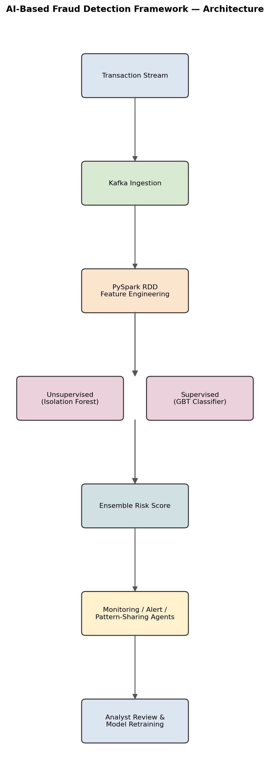
Figure 3.1 — Distributed fraud detection framework with ensemble scoring.
3. Use of PySpark & RDD Operations
Transaction records are loaded as RDDs and processed with map() to compute derived features (time-since-last-transaction, deviation from average spend), filter() to isolate transactions above a risk threshold, and reduceByKey() keyed by account-ID to build rolling per-account behavior profiles. groupByKey() supports building per-user transaction sequences for sequence-based anomaly checks. Because fraud detection needs low latency, RDDs are cached with persist(MEMORY_AND_DISK) so repeated scoring against the same rolling profile avoids recomputation.
# Building rolling per-account risk features
txn_rdd = sc.textFile("transactions.csv").map(parse_txn)

account_profile = txn_rdd.map(lambda t: (t.account_id, t)) \
.groupByKey() \
.mapValues(lambda txns: compute_rolling_features(list(txns))) \
.persist()

flagged = account_profile.filter(lambda kv: kv[1]["risk_score"] > 0.75)
print("High-risk accounts:", flagged.count())

4. Distributed Anomaly Detection
- Unsupervised methods (Isolation Forest, k-means clustering) run in parallel across partitions to flag statistical outliers without needing labeled fraud examples.
- Supervised models (gradient-boosted trees via Spark MLlib) trained on historically confirmed fraud cases run alongside for known-pattern detection.
- An ensemble score combines both approaches for the final risk score.
Aspect | Unsupervised (Isolation Forest) | Supervised (GBT Classifier)
Needs labeled fraud data? | No | Yes
Detects novel fraud patterns | Yes (outlier-based) | Limited to known patterns
False-positive rate | Higher | Lower (with good labels)
Retraining need | Periodic threshold tuning | Regular retraining on new labels

5. Role of Intelligent Agents
- Monitoring Agent: Watches the live transaction stream and computes real-time risk scores.
- Alert Agent: Escalates high-risk transactions to human reviewers or auto-blocks them based on severity thresholds.
- Collaborative Pattern Agent: Shares flagged pattern signatures across regions/branches so a fraud tactic detected in one location is instantly recognized elsewhere.
- Retraining Agent: Periodically retrains models using newly confirmed labels, closing the feedback loop.
6. Scalability & Distributed Computing
Data is partitioned by account-ID to keep each customer's history co-located, reducing shuffle during profile updates. Spark's checkpointing and RDD lineage ensure the pipeline recovers automatically from node failures without losing in-flight fraud checks.
7. Data Flow & Processing Pipeline
Transaction stream → Kafka → Spark Streaming → RDD feature engineering → parallel anomaly scoring (unsupervised + supervised) → agent-based triage → alert/block decision → analyst feedback → model retraining.
8. Innovation & Impact
Cross-branch pattern sharing between agents lets the system detect coordinated/organized fraud rings that a single-branch model would miss, while the continuous retraining loop keeps accuracy high as fraud tactics evolve.

Question 4: Autonomous Supply Chain Optimization System
(Marks: 10)
1. Problem Understanding & Requirements
The system must optimize inventory levels, logistics routing, and demand forecasting simultaneously across many warehouses/distribution centers, minimizing cost while maintaining service levels, and allowing decentralized, near-autonomous decision-making at each node of the supply chain.
2. System Architecture
- Data Layer: Historical sales, inventory levels, supplier lead times, transportation costs, and real-time IoT tracking from warehouses/vehicles.
- Distributed Processing Layer (PySpark): RDD pipelines aggregate and transform data per warehouse/region.
- Forecasting Layer: Distributed time-series demand forecasting models (e.g., Spark MLlib regression/ensemble models) per SKU-region.
- Optimization Layer: Solves inventory reorder and routing optimization (e.g., linear programming per node).
- Multi-Agent Layer: One agent per warehouse/logistics node negotiates with neighboring agents for stock transfers and routing decisions.
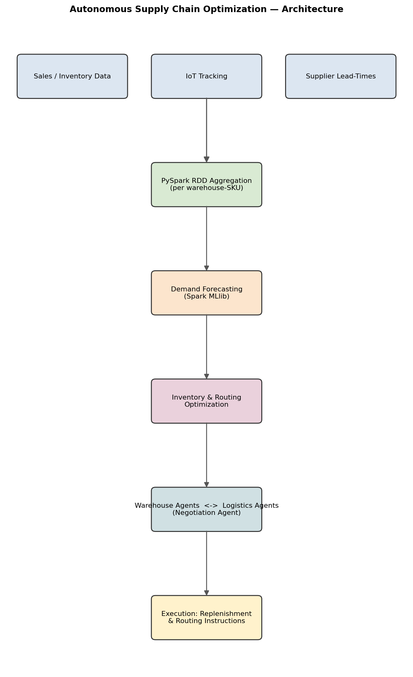
Figure 4.1 — Distributed supply chain optimization architecture with decentralized agents.
3. Use of PySpark & RDD Operations
Sales and inventory RDDs are transformed with map() to compute daily/weekly demand per SKU, reduceByKey() keyed by (warehouse, SKU) to aggregate consumption, and join() to merge demand data with supplier lead-time and transportation-cost tables. flatMap() expands multi-leg shipment routes into individual edge records for the logistics graph. Large historical datasets are cached with persist() since the forecasting stage iterates over the same RDD multiple times during model training.
# Aggregating demand per (warehouse, SKU) and joining with lead-time data
sales_rdd = sc.textFile("sales.csv").map(parse_sale)
demand_rdd = sales_rdd.map(lambda s: ((s.warehouse, s.sku), s.qty)) \
.reduceByKey(lambda a, b: a + b)

leadtime_rdd = sc.textFile("lead_times.csv") \
.map(lambda l: ((l.warehouse, l.sku), l.lead_time_days))

joined = demand_rdd.join(leadtime_rdd)
reorder_flags = joined.filter(
lambda kv: kv[1][0] > reorder_threshold(kv[1][1]))

Example: Warehouse Stock-Transfer Negotiation
Warehouse | SKU | Current Stock | Forecast Demand (7d) | Agent Action
WH-North | SKU-4521 | 120 | 300 | Requests transfer from WH-East
WH-East | SKU-4521 | 410 | 150 | Offers 150 units to WH-North
WH-South | SKU-7788 | 60 | 65 | Places new supplier order

4. Role of Intelligent Agents (Decentralized Decisions)
- Warehouse Agent: Monitors local stock levels and requests replenishment or offers surplus to nearby agents.
- Logistics Agent: Selects cost/time-optimal routes and consolidates shipments dynamically.
- Demand-Forecast Agent: Continuously updates local demand predictions from the latest sales RDD batch.
- Negotiation Agent: Resolves conflicting requests (e.g., two warehouses needing the same limited stock) via a bidding/priority mechanism, enabling decentralized rather than centrally-dictated decisions.
5. Scalability & Distributed Computing
Because each warehouse's data and agent can be processed on a separate partition/executor, the system scales horizontally as new warehouses are added. RDD lineage provides fault tolerance so a failed forecasting job on one region's partition doesn't affect others.
6. Data Flow & Processing Pipeline
POS/IoT data → batch + streaming ingestion → RDD aggregation per warehouse-SKU → demand forecasting → inventory optimization → agent negotiation for transfers/routing → execution instructions to warehouse management systems → outcome data feeds back into the next forecasting cycle.
7. Innovation & Impact
Letting agents negotiate transfers directly (peer-to-peer) rather than routing every decision through a central optimizer reduces decision latency and lets the system react to local disruptions (e.g., a delayed shipment) without waiting for a full global re-optimization.

Question 5: Personalized Learning Analytics Platform
(Marks: 10)
1. Problem Understanding & Requirements
The platform must analyze learning behavior and performance data (quiz scores, time-on-task, video engagement, forum activity) for thousands of concurrent learners, and use this to adapt content difficulty and delivery in real time, at scale, without lag for the learner.
2. System Architecture
- Data Layer: Learning Management System (LMS) logs — clicks, quiz attempts, video watch progress, time spent per module.
- Distributed Processing Layer (PySpark): RDD pipelines compute per-student engagement and mastery metrics.
- Analytics Layer: Learner clustering and performance-prediction models identify at-risk students and mastery levels per topic.
- Intelligent Agent Layer: Per-student tutoring agents adapt content sequencing and difficulty.
- Delivery Layer: Adaptive content recommendation served back to the LMS front-end in real time.
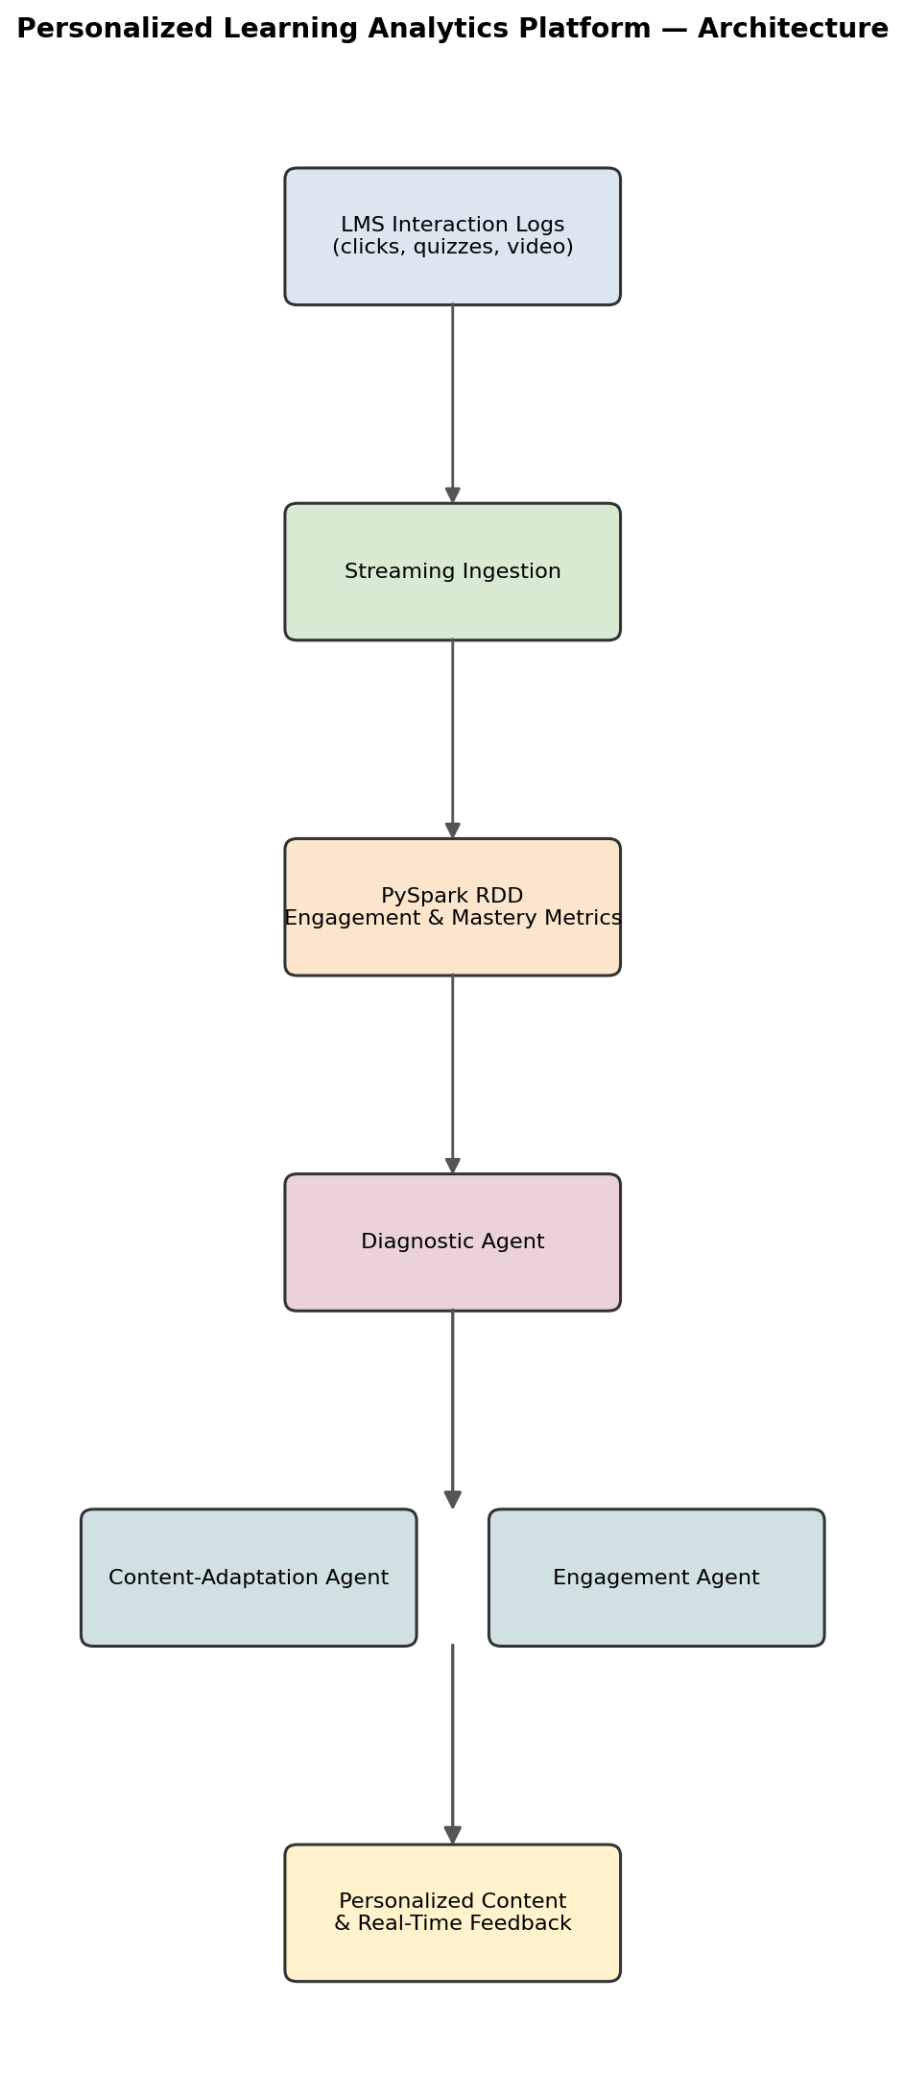
Figure 5.1 — Personalized learning analytics and adaptation pipeline.
3. Use of PySpark & RDD Operations
Interaction logs are loaded as RDDs and processed with map() to compute per-event scores (correct/incorrect, time taken), filter() to remove incomplete or test-account records, and reduceByKey() keyed by student-ID to aggregate mastery scores per topic. groupByKey() builds a per-student sequence of attempts for trend analysis (improving vs. struggling). join() merges student performance RDDs with the course's topic-difficulty metadata to compute a mastery-adjusted difficulty recommendation. Iterative clustering (e.g., k-means on engagement features) benefits from persist() to cache the RDD across iterations.
# Computing per-student mastery scores per topic
events_rdd = sc.textFile("lms_events.csv").map(parse_event) \
.filter(lambda e: not e.is_test_account)

mastery_rdd = events_rdd.map(lambda e: ((e.student_id, e.topic), e.correct)) \
.reduceByKey(lambda a, b: a + b) \
.mapValues(lambda correct_count: correct_count / attempts_per_topic)

topic_meta = sc.textFile("topic_difficulty.csv").map(parse_topic)
adaptive_plan = mastery_rdd.join(topic_meta) \
.mapValues(lambda mv: recommend_next_content(mv[0], mv[1]))

Example: Student Mastery Snapshot & Adaptive Action
Student | Topic | Mastery Score | Engagement | Agent Decision
S-3391 | Linear Algebra | 0.42 | Low (2 attempts, long gaps) | Remedial video + easier quiz
S-3391 | Probability | 0.88 | High | Advance to next module
S-4820 | Probability | 0.55 | Medium | Practice set + hint prompts

4. Adaptive Learning through Intelligent Agents
- Diagnostic Agent: Continuously estimates each learner's mastery level per topic from the latest interaction RDD batch.
- Content-Adaptation Agent: Chooses the next best content unit (easier remedial content or advanced material) based on the diagnostic agent's output.
- Engagement Agent: Detects disengagement signals (long inactivity, repeated failures) and triggers motivational nudges or instructor alerts.
- Feedback Agent: Delivers real-time, personalized feedback immediately after each quiz/activity rather than waiting for batch grading.
5. Scalability & Distributed Computing
Data is partitioned by student-ID so each learner's full interaction history is processed together, minimizing shuffle. Spark's horizontal scalability allows the platform to support thousands of concurrent learners by simply adding executor nodes during peak periods (e.g., exam season).
6. Data Flow & Processing Pipeline
LMS interaction events → streaming ingestion → RDD cleaning/aggregation per student → mastery & engagement scoring → agent-driven content adaptation decision → personalized content/feedback delivered to the learner → new interaction data flows back into the pipeline for continuous refinement.
7. Innovation & Impact
Real-time, agent-driven adaptation (rather than periodic batch-only reports for instructors) lets the platform intervene while a learner is still struggling in the same session, improving retention and reducing dropout risk at scale.
Rubrics for Calculation
Weightage — Problem Understanding & Requirement Analysis: 10% | System Architecture Design: 20% | Use of PySpark & RDD Operations: 15% | Intelligent Agent Integration: 15% | Scalability & Distributed Computing Design: 10% | Data Flow & Processing Pipeline: 10% | Innovation & Creativity: 10% | Clarity, Presentation & Documentation: 10%

Criteria | Excellent (5) | Good (4) | Average (3) | Poor (2)
Problem Understanding & Requirement Analysis | Clearly defines problem, objectives, and constraints | Mostly clear with minor gaps | Basic understanding | Unclear or incorrect
System Architecture Design | Complete, scalable, well-structured architecture with diagrams | Good design with minor issues | Basic design, lacks detail | Poor/incomplete
Use of PySpark & RDD Operations | Efficient and correct use of RDD transformations/actions | Mostly correct usage | Limited or partial use | Incorrect/missing
Intelligent Agent Integration | Strong integration with clear agent roles and logic | Good integration | Basic integration | Poor/no integration
Scalability & Distributed Computing Design | Clearly addresses scalability, fault tolerance, parallelism | Covers most aspects | Limited consideration | Not addressed
Data Flow & Processing Pipeline | Clear, logical, and well-defined data flow | Mostly clear | Some gaps | Poorly defined
Innovation & Creativity | Highly innovative, realistic, and impactful solution | Some innovation | Basic idea | No originality
Clarity, Presentation & Documentation | Very clear, neat diagrams, well-organized report | Mostly clear | Somewhat organized | Poor presentation

